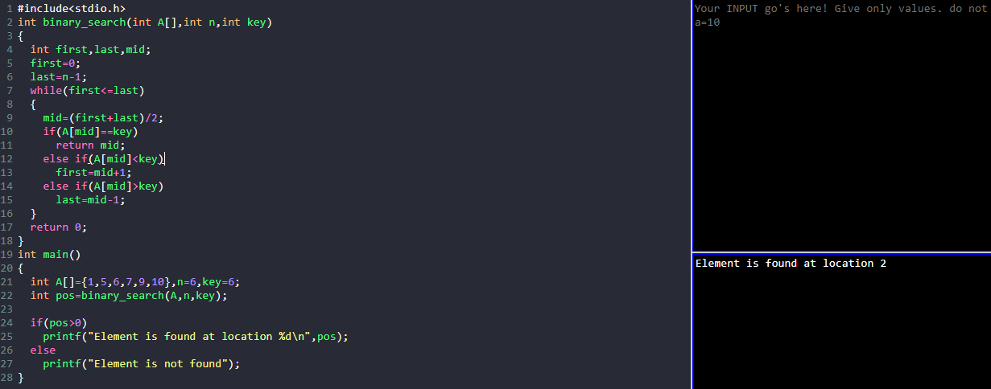#include<stdio.h>

int binary_search(int A[],int n,int key)

{

int first,last,mid;

first=0;

last=n-1;

while(first<=last)

{

mid=(first+last)/2;

if(A[mid]==key)

return mid;

else if(A[mid]<key)

first=mid+1;

else if(A[mid]>key)

last=mid-1;

}

return 0;

}

int main()

{

int A[]={1,5,6,7,9,10},n=6,key=6;

int pos=binary_search(A,n,key);

if(pos>0)

printf("Element is found at location %d\n",pos);

else

printf("Element is not found");

}